

School of Computer Science and Artificial Intelligence

Lab Assignment # 5

Name of Student: Pvamshikrishna
Enrollment No.: 2303A51452. Batch No : 21

Task Description #1 (Transparency in Algorithm Optimization) Task: Use AI to generate two solutions for checking prime numbers:-
- Naive approach(basic),
- Optimized approach

Prompt:- Generate Python code for two methods to check if a number is prime. One should be a basic method.
The other should be an optimized method using square root. Also explain the time complexity and compare both methods.

Code:-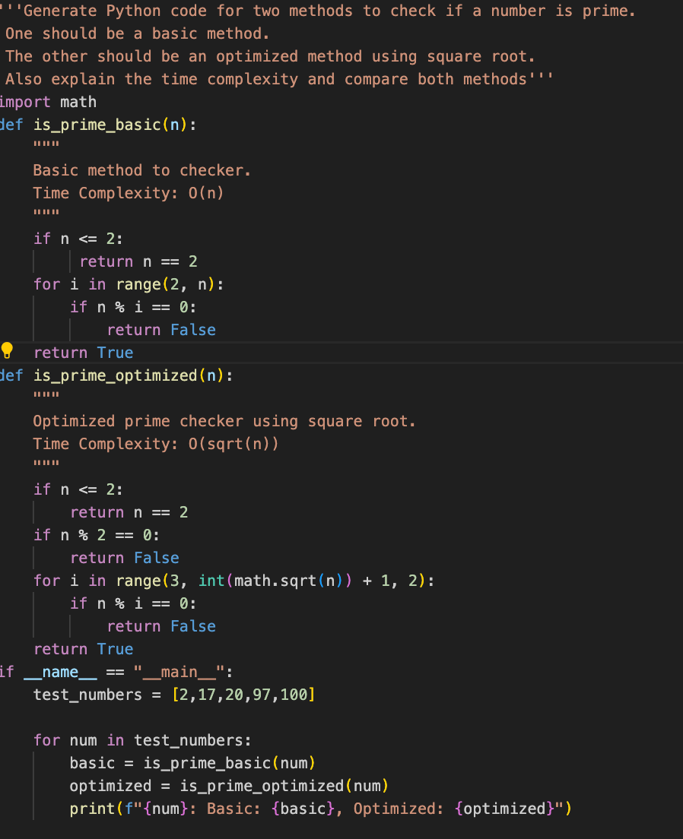
--,
Output:-

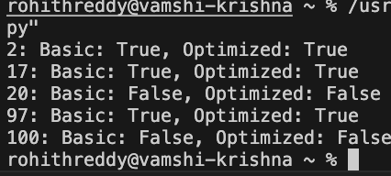


Justification:-
The program includes two methods for checking prime numbers: a naive approach that checks divisibility from 2 to n-1, and an optimized approach that reduces the number of checks by eliminating even numbers and using a 6k ± 1 rule. Additionally, it handles invalid input by catching Value Error exceptions when the user inputs non-integer values. This ensures robustness and user-friendliness.

Task Description #2 (Transparency in Recursive Algorithms) Objective: Use AI to generate a recursive function to calculate Fibonacci numbers.
Instructions:
- Ask AI to add clear comments explaining recursion.
- Ask AI to explain base cases and recursive calls.

Prompt:-
Generate a recursive Python function to calculate Fibonacci numbers. Take the number as input from the user.
Print the Fibonacci result for that input.
Add comments explaining base case and recursive call

Code:-
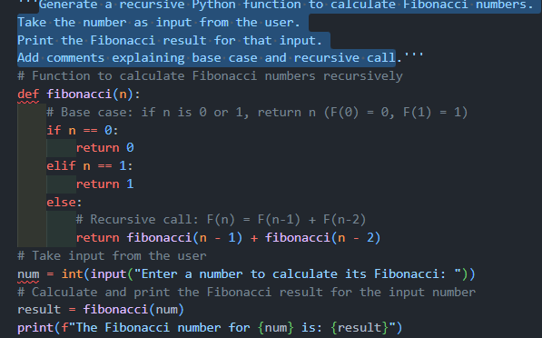

Output:-
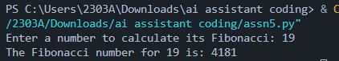

Justification:-
Recursion is a programming technique where a function calls itself to solve a problem. In this case, the `fibonacci` function calculates the nth Fibonacci number by recursively calling itself with smaller values of n until it reaches the base cases (n=0 or n=1). The base cases are essential because they stop the recursion and provide a direct answer for the simplest subproblems. The recursive calls break down the problem into smaller subproblems, which are then solved by further recursive calls.

Task Description #3 (Transparency in Error Handling)
Task: Use AI to generate a Python program that reads a file and processes data.
Prompt:-
Generate a Python program that asks the user to enter a file name. Read the file and count the number of lines.
Use proper exception handling.
Display appropriate error messages if the file is not found or cannot be accessed
Code:-
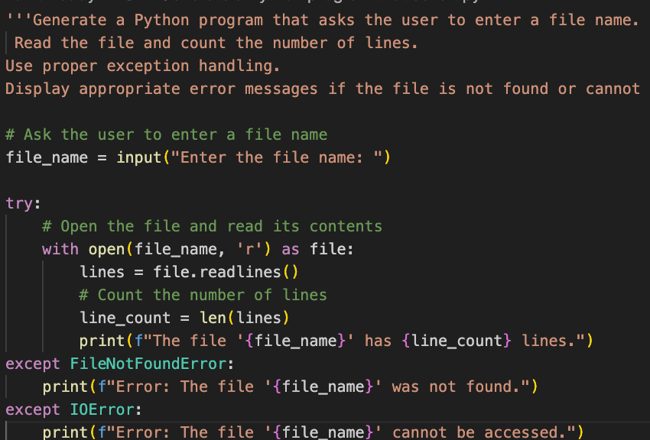
Output:-
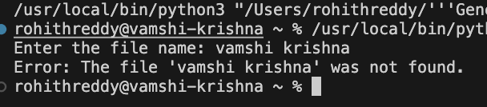

Justification:-
The code handles various exceptions that might occur during file reading: FileNotFoundError: Raised when the specified file does not exist.
IOError: Raised when an I/O error occurs while trying to read the file. Exception: Catches any other unexpected errors.

Task Description #4 (Security in User Authentication)
Task: Use an AI tool to generate a Python-based login system.
Analyze: Check whether the AI uses secure password handling practices.
Prompt:-
Generate a Python login system that takes username and password from user input. Validate the credentials.
Then improve it using password hashing. Keep inputs dynamic.

Code:-
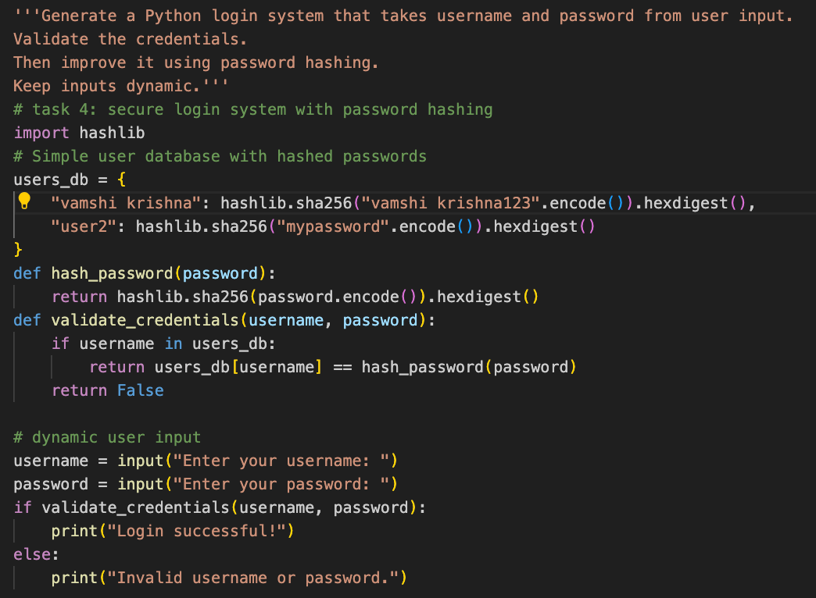

Output:-
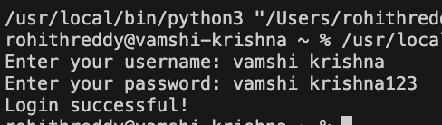

Justification:-
Secure password handling is crucial to protect user data. By hashing passwords, we ensure that even if the database is compromised, the actual passwords remain secure. Using a strong hashing algorithm like SHA-256 adds an additional layer of security. This approach prevents storing plain-text passwords, reducing the risk of unauthorized access.

Task Description #5 (Privacy in Data Logging)
Task: Use an AI tool to generate a Python script that logs user activity (username, IP address, timestamp).
Analyze: Examine whether sensitive data is logged unnecessarily or insecurely.

Prompt:-
Generate a Python script that takes username and IP address as user input. Log the username, IP address, and current timestamp into a file.
Then improve it by masking sensitive data and add clear comments
Code:-
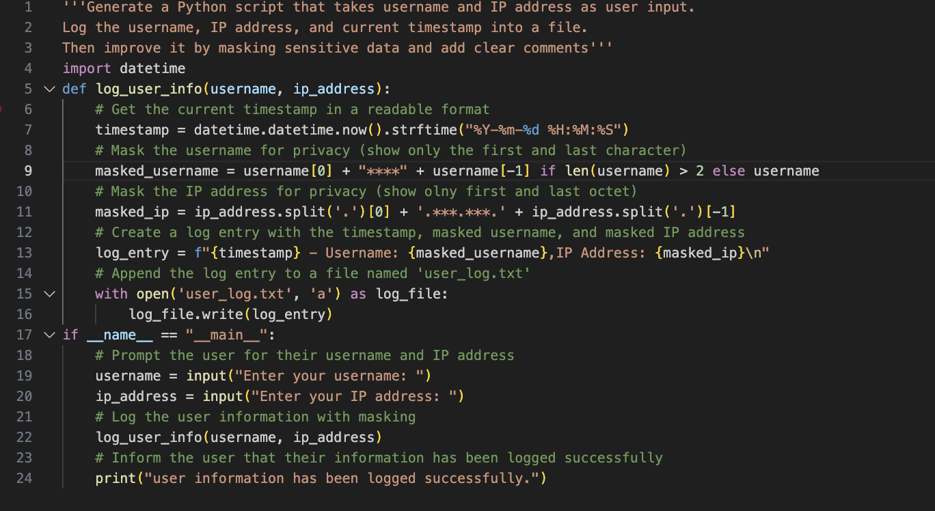
Output:-
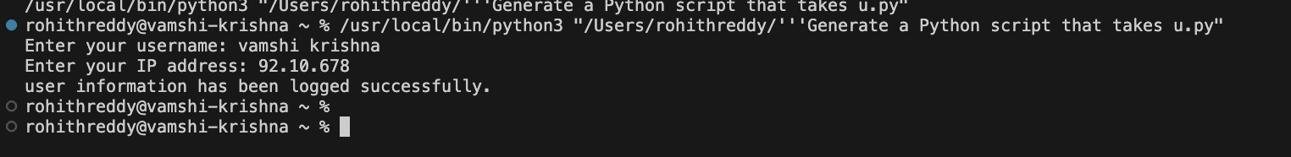

Justification:-
The code handles various exceptions that might occur during file reading: FileNotFoundError: Raised when the specified file does not exist.
IOError: Raised when an I/O error occurs while trying to read the file. Exception: Catches any other unexpected errors.

